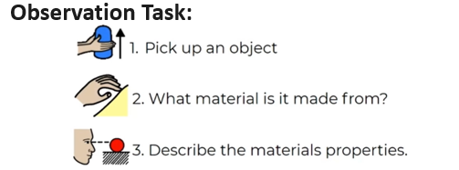

Choose at least 4 objects made from different materials.

Record your observations in written sentences.

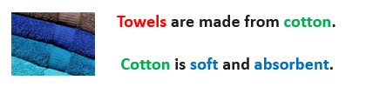
e.g.

Key Words
Some types of Materials:
Glass plastic wood cotton metal fabric
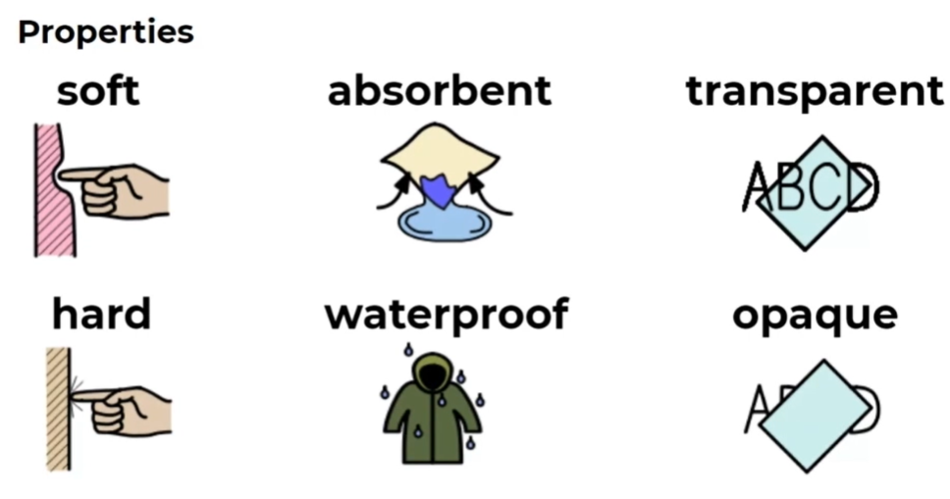
flexible / bendy shiny

